MongoDb task:

I have used users collection and inserted all the documents given in the task file and performed all the querries also attached the screen shots

1. Find all the information about each products

Solution:db.users.find()

C:\Users\LENOVO\Pictures\find all.PNG

1. Find the product price which are between 400 to 800

Solution : db.users.find({

$and:[ {product_price:{$gte:400}} , {product_price:{$lte:800}} ]

})

C:\Users\LENOVO\Pictures\question 2.PNG

1. Find the product price which are not between 400 to 600

Solution:db.users.find({$or:[{product_price:{$lt:400}},{product_price:{$gt:600}}]})

C:\Users\LENOVO\Pictures\question3.PNG

1. List the four product which are grater than 500 in price

Solution:db.users.find({product_price:{$gte:500}})

C:\Users\LENOVO\Pictures\question 4.PNG

1. Find the product name and product material of each products

Solution: db.users.find().forEach(function(document){

print(“product Name”+document.product_name,”product Material”+document.product_material)

})



1. Find the product with a row id of 10

Solution : db.users.find({id:”10”})

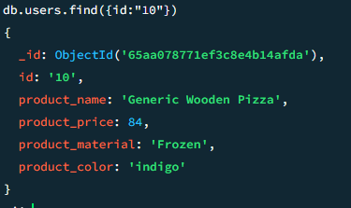

1. Find only the product name and product material

Solution : db.users.find().forEach(function(document){

print(“product Name”+document.product_name,”product Material”+document.product_material)

})



1. Find all products which contain the value of soft in product material

Solution: db.users.find({product_material:”Soft”})

C:\Users\LENOVO\Pictures\question8.PNG

1. Find products which contain product color indigo  and product price 492.00

Solution : db.users.find({$or :[{product_color:”indigo”},{product_price:492}]})

C:\Users\LENOVO\Pictures\question 9.PNG

*There is no product with both product_color as indigo and product price as 492

So i tried with or operator so that it shows products with either color indigo or price as 492

1. Delete the products which product price value are same

Solution:db.users.deleteMany({$or:[{product_price:36},{product_price:47}]})

C:\Users\LENOVO\Pictures\question 10.PNG